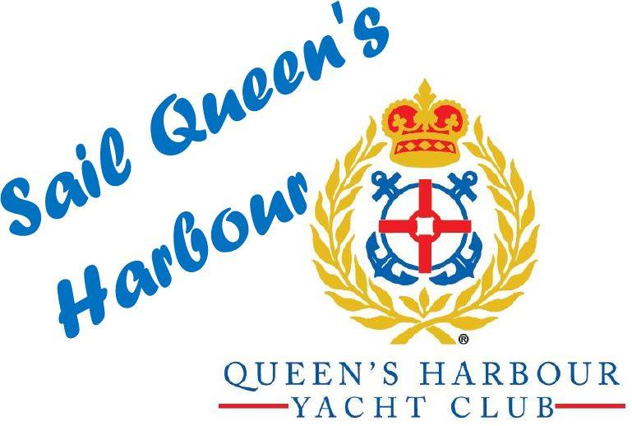

August 10, 2018
Dear Sailing Parent-

The fall youth sailing season will soon be upon us, commencing September 6, following the successful June and July SQH summer camps!
The fall programs are open to all youth residing in Queens Harbour and our Neighbors living outside of our Queen's Harbor community - when the youth's family joins the QHYC or their youth is enrolled as a Youth QHYC member.
- Our Fall Camp for 'Dolphins', 6 to 8 years+, and any beginners who would like to get started, commences Wednesday, September 12, from 4-6 PM, and each Wednesday thereafter, and ending on October 31. The Dolphins will be led by Kurt Bobst, a US Sailing Association Certified Instructor and Certified Life Guard.

- Our Fall SQH Camp for 'Racing Rascals' commences on Thursday, September 6, from 4-6:30 PM until November 1. This is open to 8 year + 'graduates' from Dolphin program and includes more serious sailing, with Opti inter-club racing for youth who qualify. The Rascals will be led by Tim Brustoski, a US Sailing Certified Instructor and Life Guard.

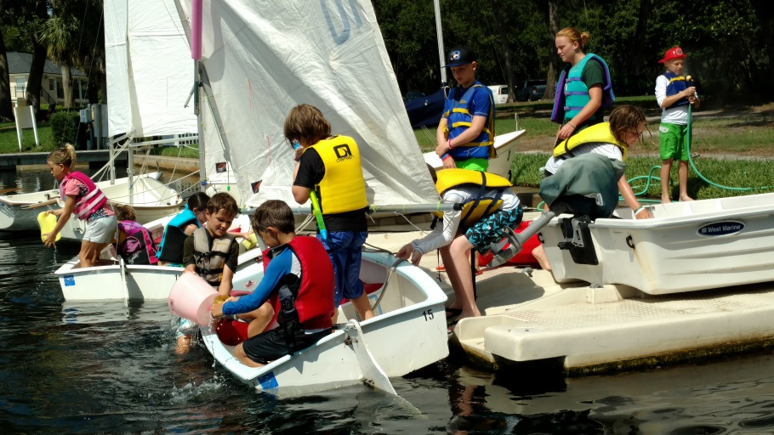
Our goals for Dolphins: Safety. fun and learning to both sail, understand and executing the basic seamanship tasks related to Opti and Bauer sailing- with advancement to Rascals when qualified and interested. Weather permitting kayaking, swimming and games included.
Our goals for Rascals: Safety, advanced sailing / racing and 'serious' fun. The curriculum will be the US Sailing Small Boat Sailor Certification program, with on the water, white board instruction and some 'homework', with each youth advancing step by step at their own speed.

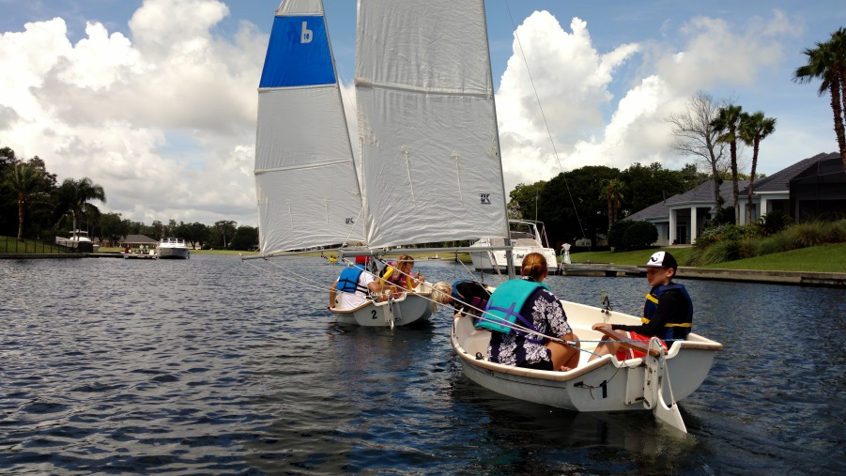
QHYC Membership: Annual (4/1 - 3/31) Membership in QHYC. Adult ($225) -Covers all family youth; Youth ($75-One family Youth); ($100-Two+ family youth).
QHYC Instruction: Dolphins or Rascals: $160.00 for each youth enrolling in either fall program.
If interested please register, ASAP, at "SailQH.com." Your checks for membership (if new or renewing) and instruction: Payable to the "QHYC", c/o Martin Rees, Treasurer QHYC, 13639 Queens Harbour Boulevard, Jacksonville, FL. Early registration assists staffing and planning.

Sincerely,

Gil Wright, Chair (904-742-0556);
Nick Simonis, Commodore;
Jack Feeney, Senior Sailing Instructor

